UNIVERSITY OF RWANDA

COLLEGE OF SCIENCE AND TECHNOLOGY
SCHOOL OF ICT
COMPUTER ENGINEERING
YEAR 3
GAKO CAMPUS

ON 2nd FEB 2026

GROUP 1 MEMBERS:
1.DAVID RUBIMBURA 221014566
2.REOBOTH IRADUKUNDA 223026686
3.VALENTIN MUHIRE 223026676

MODULE: MOBILE APPLICATION SYSTEM AND DESIGN
TOPIC: SCREENSHOTS OF THE OUTPUTS OF EACH QUESTION

SCREENSHOTS OF THE OUTPUTS OF EACH QUESTION
Q1: Write a Dart function named `welcomeMessage` that prints a welcome message for the school system.
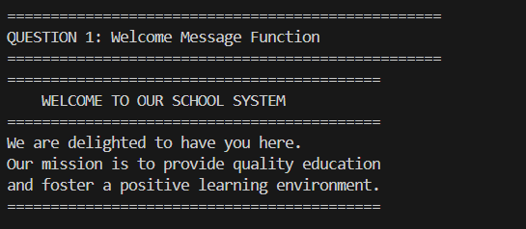
Q2: Write a function named `createStudent` that uses named parameters (`name` and `age`) and prints the student details.
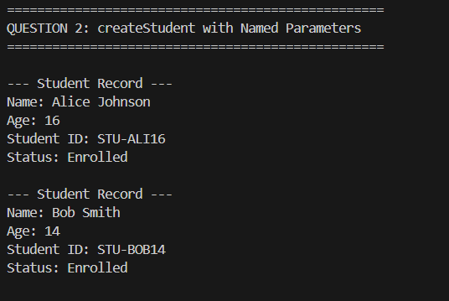
Q3: Write a function named `createTeacher` with one required parameter `name` and one optional parameter `subject`. If subject is not provided, print 'Subject not assigned'.

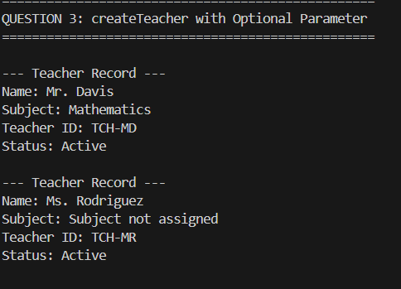

Q4: Create a class named `Student` with `name` and `age`, and a constructor to initialize these values.

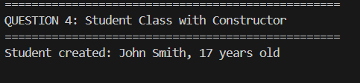

Q5: Create an object of `Student` and print the student’s name and age.
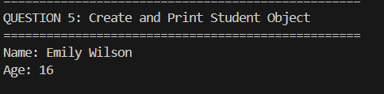
Q6: Create a class `Person` with a variable `name` and a function `introduce()` that prints the name.
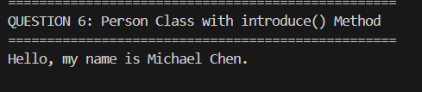
Q7: Make `Student` inherit from `Person` and call `introduce()` from a `Student` object.
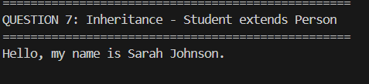
Q8: Create an abstract class `Registrable` with a function `registerCourse(String courseName)`.
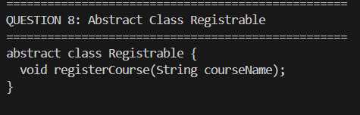
Q9: Make `Student` implement `Registrable` and implement `registerCourse` to print the student name and course.
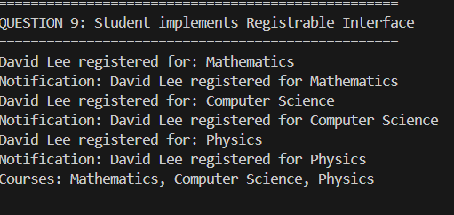
Q10: Create a mixin `AttendanceMixin` that stores an attendance counter and has a function `markAttendance()` to increase attendance.
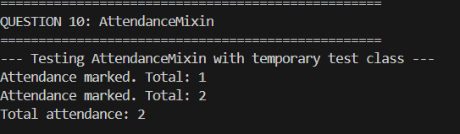
Q11: Apply `AttendanceMixin` to `Student`. Mark attendance 3 times and print the attendance.
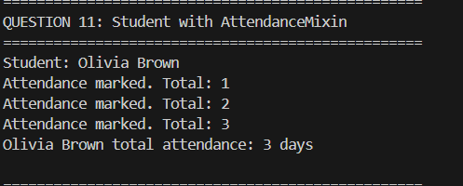
Q12: Create a List storing multiple `Student` objects. Add 3 students.
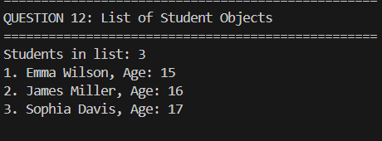
Q13: Create a Map where the key is student ID and value is a `Student`. Print all student names.
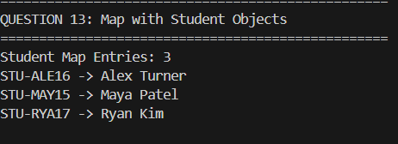
Q14: Use an anonymous function to print all student names from the list.
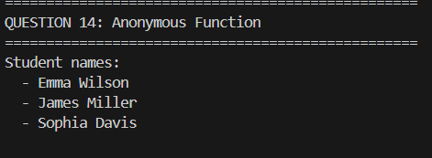

Q15: Write an arrow function that takes a student name and prints a greeting message.
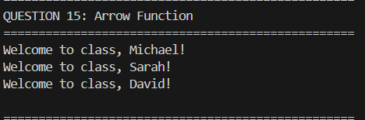

Q16: Write an async function `loadStudents()` that waits 2 seconds and returns the list of students.
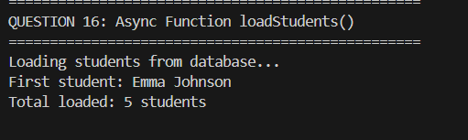
Q17: In main(), call `loadStudents()`, use await, and print the number of students loaded.
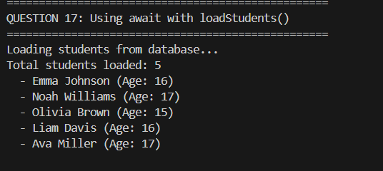
Q18: Explain in your own words: why mixins are useful, and how inheritance and mixins are different.
WHY MIXINS ARE USEFUL:
1. Code Reuse Across Hierarchies: Share functionality between unrelated classes
2. Avoid Diamond Problem: No ambiguity when same method exists in multiple parents
3. Flexible Composition: Add behaviors like building blocks, not rigid hierarchies
4. Single Responsibility: Keep classes focused, mixins handle cross-cutting concerns
5. Testability: Mixins can be tested independently

DIFFERENCES BETWEEN INHERITANCE AND MIXINS:
-------------------------------------------------
INHERITANCE MIXINS
-------------------------------------------------
"is-a" relationship "has-a" capability
Single parent only Multiple mixins
Deep class hierarchy Flat composition
Tight coupling Loose coupling
Compile-time resolution Linearized order
Hard to change later Easy to add/remove
-------------------------------------------------

PRACTICAL EXAMPLE IN OUR CODE:
Inheritance: Student IS-A Person (gets basic identity)
Mixin 1: Student HAS Attendance tracking capability
Mixin 2: Student HAS Notification capability
Result: Flexible, reusable behaviors without complex hierarchy

Q19: Create a new mixin `NotificationMixin` that prints a message when a student is registered to a course. Apply it to `Student`.
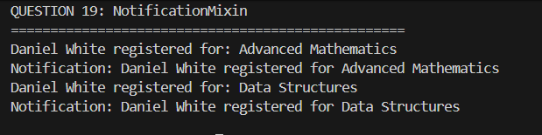

Q20: Write a short paragraph explaining how learning Dart helps you understand Flutter.

Dart is the foundation of Flutter development. By learning Dart, we gain:

1. WIDGET UNDERSTANDING:
• Flutter widgets are Dart classes
• State management uses Dart's reactive programming

2. ASYNC OPERATIONS:
• Flutter apps heavily use async/await for API calls
• Future and Stream are core Dart concepts

3. OBJECT-ORIENTED STRUCTURE:
• Flutter's widget tree is built using Dart OOP
• Inheritance and mixins create reusable UI components

4. TYPE SAFETY:
• Dart's strong typing prevents runtime errors in Flutter
• Null safety ensures robust mobile applications

5. HOT RELOAD:
• Dart's JIT compiler enables Flutter's fast development cycle
• Quick iteration is possible because of Dart's architecture

Learning Dart first makes Flutter development intuitive because every Flutter app is essentially a well-structured Dart program with a UI layer.

